**Hi Bob** – as requested, here is my draft for the magazine article. I hope I’ve covered most things without going over the top and that the photos will be good enough for your needs. Note that since I made reference to it in the intro I’ve included a shot of the intarsia Santa I made if you feel you should include it. I’m not 100% happy with it, particularly the facial expression and belt buckle and if you feel it’s better to leave it out I have no problem with that as it seems somewhat amateurish compared with the usual projects you feature.

I’m really looking forward to see how you wield your editor’s pen and what you finish up with and I certainly don’t envy you the task!

If you need more information please contact me.

One comment ref my Bio; I’ve referenced my website which at the moment hasn’t gone live. I will have it up and running before the magazine hits the press to hopefully glean some publicity from the magazine. Believe me or not! LOL!

Hope all at Fox Chapel managed to pull in an Easter break and find time to enjoy your families and recharge the batteries.

Thanks again

Jim

17 Abril, 2011

## Introduction

Caption scrollingsanta2.jpg or choose alternative….

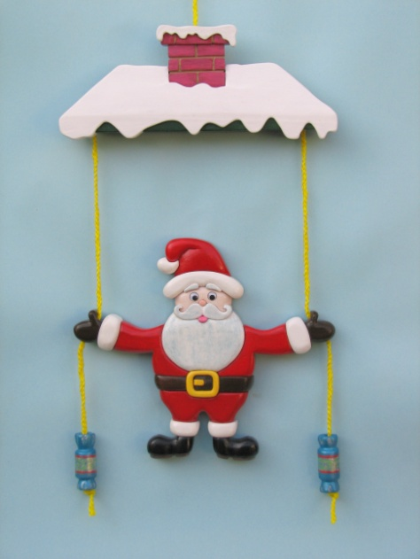

Just over 15 years ago I bought from a Mexican craft market for less than a dollar a popular folk art toy climbing clown which subsequently hung just inside the entrance to my home. It was a simple ‘cookie cutter’ MDF cut out, very primitively decorated, but despite its humble fabrication and appearance it proved to be a magnet to any young visitors. Pulling the cords and watching the clown rise to the top of its pivot bar always brought a smile to a child’s face – not to mention a few adults too! Two years back, just before Christmas, the clown received one tug too many from an over exuberant pair of young hands and one of the arms broke. Rather than glue it back together I decided to make a replacement as a scrolled project and with the festive season almost upon us it was an easy decision to choose a colorful jolly Santa as the climber and to replace the simple pivot bar with a decorative rooftop for Santa to climb up to.

I cut the pattern segmentation style from a single board and decorated the pieces with bright acrylic paints. I designed the pattern to be easy to cut and apart from needing a little care to scroll around a slightly devilish moustache twirl it should be well within the capabilities of relative newcomers to scrolling. I used a minimum number of tools to shape and finish the project, keeping it well within the grasp of scrollers with limited workshop resources.

The pattern is cut using a Flying Dutchman #1 Ultra Reverse blade. This may seem a strange choice since normally one would use a heavier blade choice for the 7/8” thick board. Nevertheless, I find that by cutting at a reasonably fast blade speed, feeding the wood very gently into the blade so as not to flex it, that these blades give a very precise cut, a small kerf and, since the cutting is slower than with a heavier blade, allow the feed to be controlled more easily.

Since cutting my first Climbing Santa I’ve produced several more, including one cut and decorated intarsia style, but whilst the latter certainly has its merits I do feel that as a functional toy and a Christmas showpiece this project is better suited to being brightly painted.

This Climbing Santa design was recently offered as a group challenge in the segmentation and intarsia section of the message board at [www.scrollsawer.com/forum](http://www.scrollsawer.com/forum) where it received a very lively response and produced a number of creative and amusing variations to my original design. It’s definitely a fun project, open to different interpretations, and one which can easily be completed over a weekend, but if you give it a try, be warned! Once you have made one of these colorful climbers and shown it around you’re sure to be asked to make more!

# Materials

- 10” wide x 7/8” thick x 18” long, white pine board or similar reasonably strong softwood, sanded flat to the thickness stated

- 12” x 10” x 1/8” plywood, masonite or MDF to use as backer material

- 1” diam. wooden beads or dowel pegs (2 off) to use as cord stops

- 8ft x 1/8” diam. brightly colored non-elasticated cord

- water based ‘tacky’ wood glue

- sandpaper, preferably clothbacked, 120’s and 240’s grit

- 2” wide clear packing tape or blue painter’s tape

- spray-on or roll-on adhesive

- wood sealant –shellac or acrylic based

- acrylic based wood primer, preferably off white color

- hobby acrylic paints –various colors

- clear satin acrylic varnish

-a pair of 5/16” diam. plastic ‘wobbly’ eyes,

- semi transparent wax paper for edge gluing

- pencil HB grade

### Tools

Flying Dutchman #1 Ultra Reverse scroll saw blade, or equivalent

Rotary power carving tool with the following accessories:

* Fine grit large drum sander
* Fine grit small drum sander
* Fine-grit safe-end small cylinder-shaped carbide point bit
* Small cone shaped engraving bit (stone or metal)

Drill press or hand power drill with 3/16” and 1/32” diam. standard twist drills and a 5/16” center point twist drill

- homemade ‘lollipop/popsicle’ sanding stick with 120’s grit - making instructions are provided

- fine haired 1/2”wide flat artist’s paint brush or similar

- Small pincer clamps

- (Optional) Bench mounted disc sander or belt sander to reduce the thickness of certain parts - alternatively, hand sand on a sheet of 80’s grit sandpaper

Note: Fit your saw table with a proprietary or home-made zero tolerance insert to give support when cutting small parts and prevent them from dropping through the table.

## Caption 1 Sanding & shaping tools

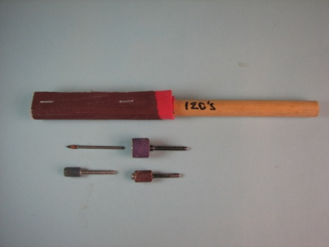

The ‘lollipop or popsicle’ sanding stick shown is used like a rasp to quickly and easily shape the larger parts of the pattern. Make this by taking a 10” length of ½” diam. dowel and glue around one end a piece of 6” wide x 1/8” thick ‘foamy’ or soft rubber cushioning material. Wrap a 6” wide piece of 120’s grit cloth backed sandpaper or sanding belt twice around the cushioning material and staple or tack it to one side of the dowel.

## Cutting the patterns

Cut the Santa pattern first. Cut the mitten drill blanks, separating the mittens from the jacket cuffs. Do not cut out the actual mittens. Cut the rest of the parts beginning with the mustache and face parts so as to have plenty of wood on the table to manipulate when cutting. Pencil mark the lower face of each part with an arrow indicating its upper top edge. For similar shaped parts identify which part is the pattern left hand side and which is the right. Place each cut part into a shallow tray or box for safe keeping.  
  
Caption 2 Cutting the mustache

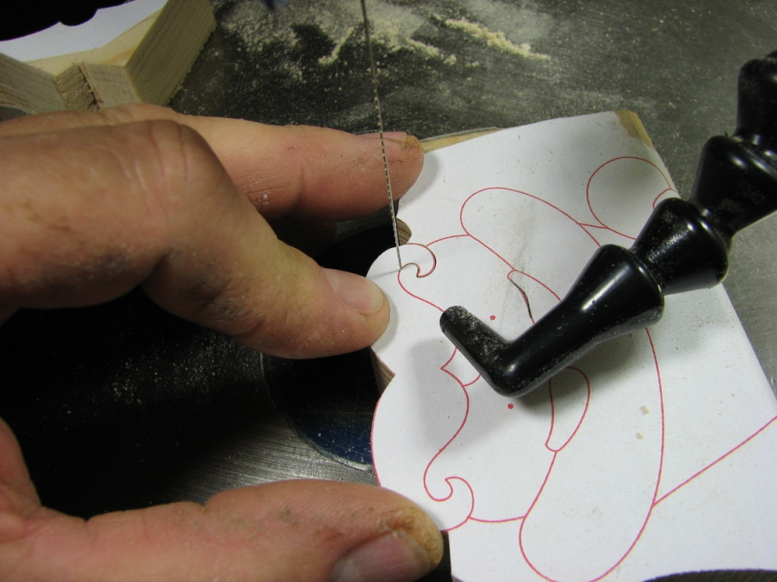

Cut the lower part of the mustache and separate it and the head parts from the beard and body parts. Cut the rest of the mustache by firmly place your left hand index finger very close to the blade. Apply sufficient downward pressure to securely hold the wood to the table. Gently feed the wood into the blade pivoting it around your index finger according to the pattern line direction.

## Caption 3 Cutting the belt buckle

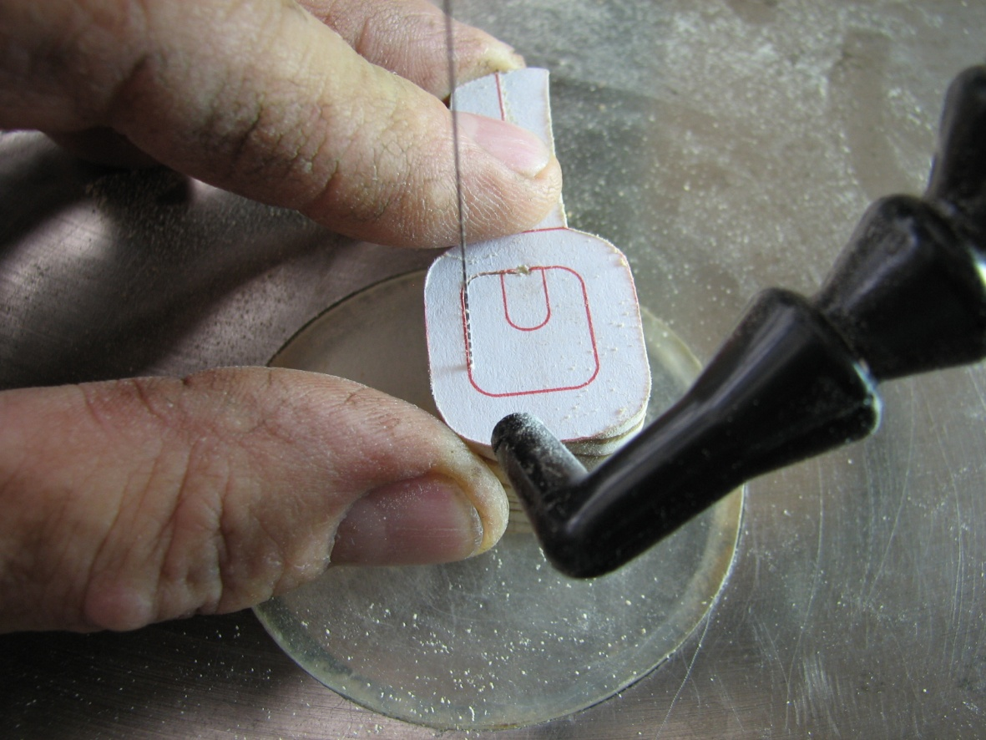

Cut out the belt buckle ring leaving it attached to one of the belt parts to help manipulate the piece on the saw table. Drill a 1/32” through hole on the buckle ring pattern line at the center of the buckle pin. Thread the scroll blade through this hole and cut out the buckle center part. Do not cut out the horizontal buckle pin!

After cutting all the Santa parts, cut out those of the roof, including the two pivot bars, and place them in a separate tray.

## Caption 4 Drilling the mitten cord holes

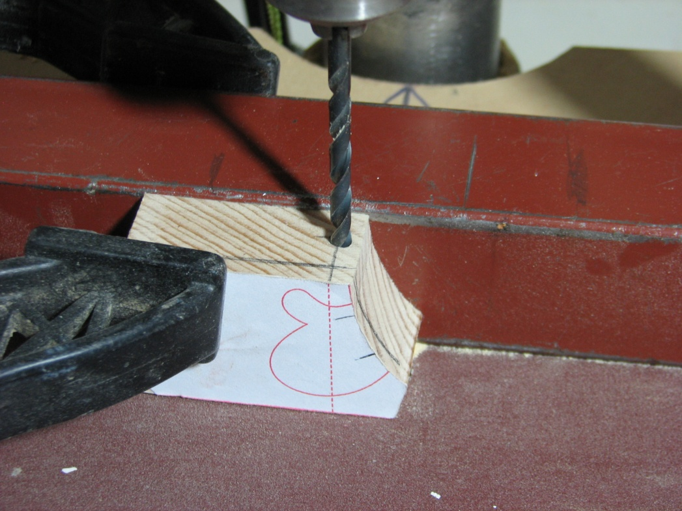

Take one of the mitten drill blanks and draw a line across its top face square to the pattern dotted cord line. Center punch mark this line at 3/8” distance from the back face of the blank. Set your drill press fence to this center mark and clamp the blank into position against it. Slowly drill a 3/16” hole through the drill blank. Repeat this operation for the other mitten drill blank.

Note: In the absence of a drill press clamp the blank either horizontally or vertically to a stable work surface and use a hand power drill to bore the holes. Drill a 1/32” pilot hole before drilling the 3/16” one.

After drilling the blanks, cut out the mittens, identify their back face and place them with the rest of the cut Santa parts

## Sanding and shaping. Part 1 – The Santa

## Caption 5 Reducing part thicknesses

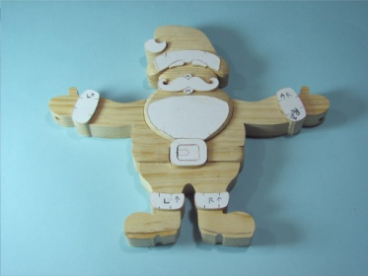

Most of the shaping of the Santa is achieved by rounding over of the parts to give the suggestion of a three dimensional form. To emphasize this effect reduce the thickness of the indicated pattern parts from 7/8” to 3/4” as shown in the image.

To reduce a part thickness, select a part and pencil a line on it’s edge face approximately 1/8” in from the pattern face. Reduce the thickness using a bench mounted disk or flat belt sander or hand sand the parts on a sheet of 80’s sandpaper taped down to a flat, smooth work surface. Whilst sanding, rotate the part frequently to remove the wood evenly down to the pencil line.

Note: Do not reduce the thickness from the back face since inaccurate sanding could cause the face to bow which would give problems during gluing of the assembly.

## Caption 6 – Shaping the pants

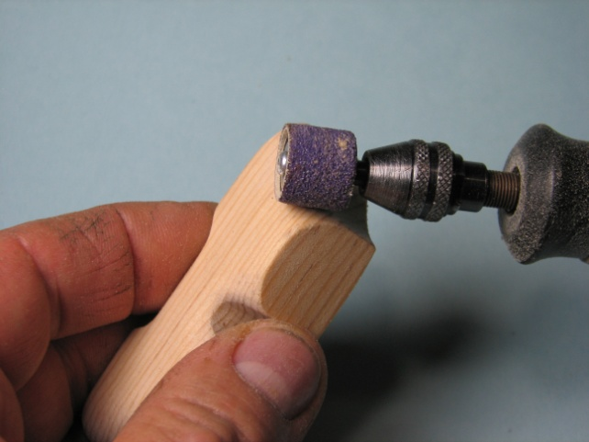

Begin by shaping Santa’s pants. Use a combination of the sanding tools to round over the outside and inside edges of the pant legs. Slightly curve the outer face of the pant top to give roundness to the waist.

### Caption 7 **Shaping the pant bottom to the pants**

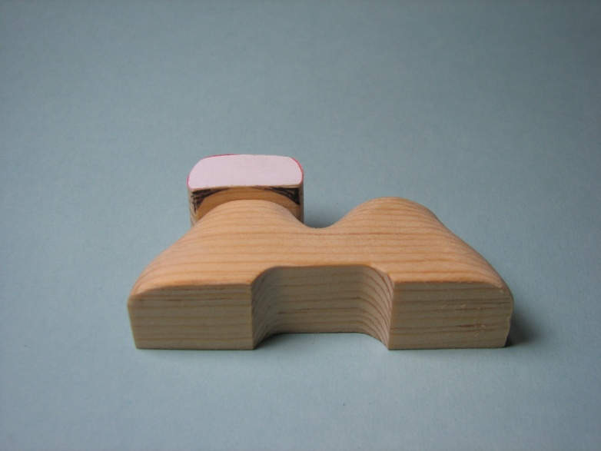

Place one of the pant bottoms against its pant leg and mark the area to be rounded over. Follow the cross section of the pant legs keeping the 1/8” height difference between the two parts. Round over the face of the part from left to right then round over the top and bottom edges of the face. Repeat this process for the other pant bottom

## Shaping continued….

Continue to shape by referencing unshaped parts to previously shaped parts to give form to the rest of the Santa in the following order:

Shape the two belt parts. Leave the buckle ring at its original thickness and slightly round over its upper face edges. Using the safe-end fine cylindrical-shaped carbide pointed bit, ‘carve’ the buckle pin into the buckle center. Smooth the carved surface with the small fine drum sander.

Shape the boots. Use the safe-end fine cylindrical-shaped carbide pointed bit to carefully carve out the shape of the soles.

Shape the jacket parts, the sleeve cuffs and the mittens.

## Caption 8 Detail of shaping the beard, mustache and face features

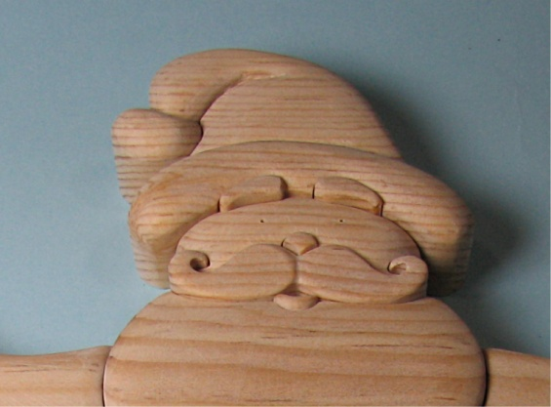

Round over the left and right side face edges of the beard to slightly less than 1/8” radius - the bottom of the radius should be slightly higher than the thickness of the jacket parts. Slope the upper 1/2” of the beard face downwards to lower the centre of its top edge 1/16” below the height of the mustache. Round over the outside points of the beard top edge to accentuate the mustache.

Slope the top edge of the mouth inwards to give it a tongue shape. Use a 1/32” drill to bore the eye centers to approximately 1/4" deep. Shape the outside edges and top edge of the face. Carefully shape the mustache with the small drum sander lowering the twirl tips towards the face to prevent them from being accidentally damaged. Lightly round over the pattern face of the nose.

## Caption 9 Shaping the cap

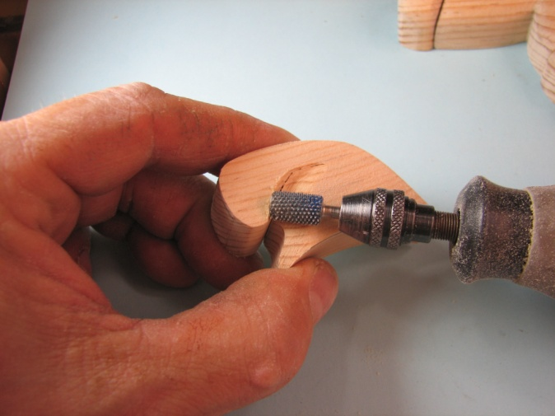

Shape the cap trim to the face rounding over its top and bottom edges. Use the safe-end fine cylindrical-shaped carbide pointed bit to shape the cap fold to the cut pattern line. Use the large drum sander to lower the pointed part of the cap to where it meets the cap bobble. Shape the rest of the cap with the large fine drum sander and round over the face edge of the cap bobble.

## Caption 10 Drilling the eye sockets

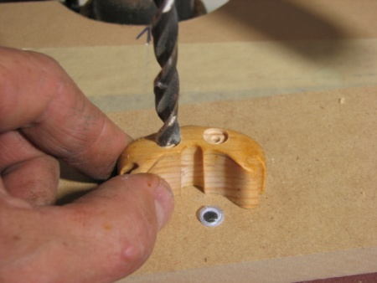

After shaping the face use the 5/16” centre point bit to drill the eye sockets 1/32” deep. Remove the sharpness of the eye socket edges with fine grit sandpaper.

## Caption 11 The shaped Santa

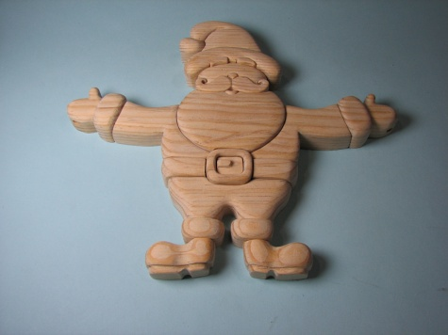

Finish the shaping by going over all the parts with 120’s grit sandpaper to smooth any rough areas and edges. Your shaped Santa should look similar to that in the image.

## Caption 12 Sanding and shaping. Part 2 – The Roof

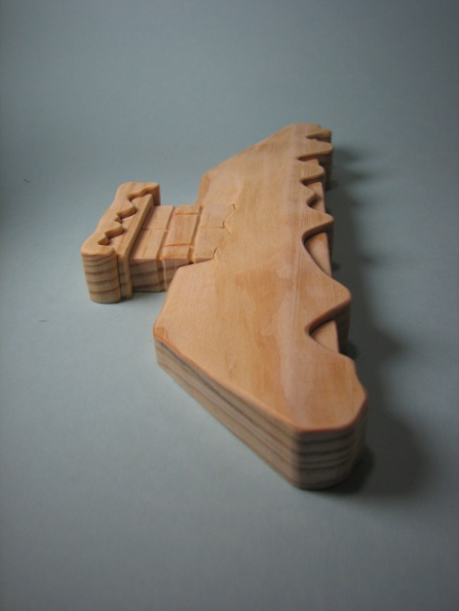

.

Reduce the height of the roof parts as indicated on the pattern. Pencil a line on the edge face of the roof ridge at 3/8” distance from the pattern face. Sand the roof to slope from the heavy dotted line on the pattern to this pencil line. Pencil mark the brick grout lines on the chimney stack and stroke the small cone-shaped engraving bit along the lines to carefully carve them out to 1/16” depth. Round over the edges of the roof parts as shown in the image and smooth finish with 120’s grit sandpaper

Presealing, painting and finishing

Apply an acrylic or shellac based wood sealant to the surfaces to be painted and leave to dry. Lightly sand the sealed surfaces with 120’s grit sandpaper to remove any roughness. Wipe away any dust using a damp lint free cloth.

Using a fine haired flat artist’s brush apply a coat of acrylic primer to the areas of the parts which will be visible after assembly. Leave to dry. Lightly sand away any imperfections with 240’s grit sandpaper.

Using acrylic colors of your choice apply 2 or 3 color coats to the parts, allowing the paint to dry completely between coats.

## Caption 13 Support dowels used during painting

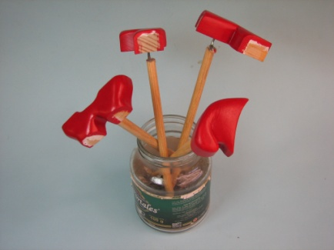

Whilst painting and drying support the parts on pin ended dowels stabbed into the back face of the part or use a small bead of hot melt glue to temporarily stick length of normal dowel to the part. Place the dowels in a stable container while the paint dries.

## Edge gluing the pattern assemblies and making the backers

Tape a copy of the Santa pattern to a flat level work surface. Tape on top of this a sheet of semi transparent wax paper. Use the pattern as a guide to edge glue the parts together. Begin by gluing around the beard part and work outwards. Apply one or two beads of ‘tacky’ wood glue to the lower parts of the edge faces and gently push the parts together. Remove any squeezed out glue with the point of a damp paint brush. Allow the glue to completely dry.

Repeat this exercise for the roof pattern parts

Note Do not clamp the parts together during the gluing/assembly process. Since this pattern is cut segmentation style there should be a kerf sized gap between the assembled parts which will be bridged by the glue beads

Allow the glue to fully cure. Carefully lift the glued assemblies away from the wax paper and place them on top of the 1/8” plywood. Pencil mark the outline of the assemblies onto the plywood. Hand draw the backer patterns approximately 1/8” inside the pencil outlines and cut out the backers. Lightly sand the backer edges and paint them with black acrylic paint. Take each assembly in turn and carefully paint black the outside border of the back face approximately 1/4" in towards the center. Apply a thin layer of tacky wood glue to the inner face of the backer and carefully place it into position on the back face of the assembly. Turn the assembly over and place a weighted object onto the painted face of the assembly using a piece of cushioning material between the two so as not to damage the painted face. Allow the backer glue to dry. Paint the outside face of the Santa backer black.

**Caption 14.** Gluing the roof pivot bars in place

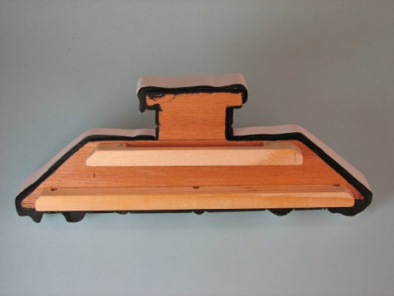

Before painting the roof backer glue the roof pivot bars in place as shown. Use pincer clamps to hold the bars tight to the backer whilst the glue cures. Paint the backer and pivot bars with black acrylic paint.

## Finishing and stringing the Climbing Santa

Spray or brush apply a satin finish acrylic varnish to the painted Santa and roof assemblies and allow 24 hours for the varnish to fully dry.

## Caption 15 String the roof pivot bars

Take two 3 ft lengths of cord and make a knot at one end of each. Thread each cord through a wooden bead, dowel or similar item to act as an end stop. Pass each cord through a mitten. Thread the cords through the outer holes in the lower pivot bar and secure their ends with a knot. Trim way any excess cord. Take a 12” length of cord and knot a small hanging loop at one end. Pass the other end of the cord through the slot between the upper pivot bar and the backer and then through the center hole of the lower pivot bar. Secure the end with a knot or staple it to the bar. Using a small bead of tacky glue to stick the ends of the cords to the back to keep them hidden when the roof is hanging from a wall.

Hang the finished Santa and roof from a suitable wall hook or similar.

To make Santa climb pull alternatively on each of the cord stops to pivot Santa, keeping both cords tensioned as you pull. As Santa pivots he will climb the cords to the roof. Releasing the end stops with cause Santa to slide down to the cord stops.

Note The decorative cord stops shown were made from 2” lengths of drilled 1/2"dowels carved and painted in the form of Christmas candies. Use your imagination to design your own stops!

Have fun!

## Jim Moss Bio

Choose caption image

Jim Moss is an ex-pat Englishman who lives in Mexico with his wife and 9 year old son. For the past 20 years he has worked around the world as a consultant industrial ceramist and project manager and began scrolling just over 3 years back as an occasional hobby to fill in spare time between work projects. He concentrates on making segmentation and intarsia pieces plus toys and boxes and designs the majority of the patterns he uses. He particularly likes to make functional and/or amusing pieces. Examples of his work along with ‘how to’ tutorials of a number of projects can be found on his web site at [www.scrollingalong.com](http://www.scrollingalong.com)